


Database Management Lab Experiment (ENCS205)

Bachelor of Technology in
Computer Science and Engineering

Submitted by
LUCKY KUMAR (2401010012)
B. Tech CSE (Core) – 4th Semester Section: A

Submitted To:

MS. Mansi Kajal

School of Engineering & Technology
K. R. MANGALAM UNIVERSITY
Sohna, Haryana 122103, India feb-2026

EXPERIMENT:10

Using the tables “DEPARTMENTS” and “EMPLOYEES” perform the following queries:
- Display the employee details, departments that the departments are same in both the emp and dept.
- Display the employee name and Department name by implementing a left outer join.
- Display the employee name and Department name by implementing a right outer join.
- Display the details of those who draw the salary greater than the average salary.

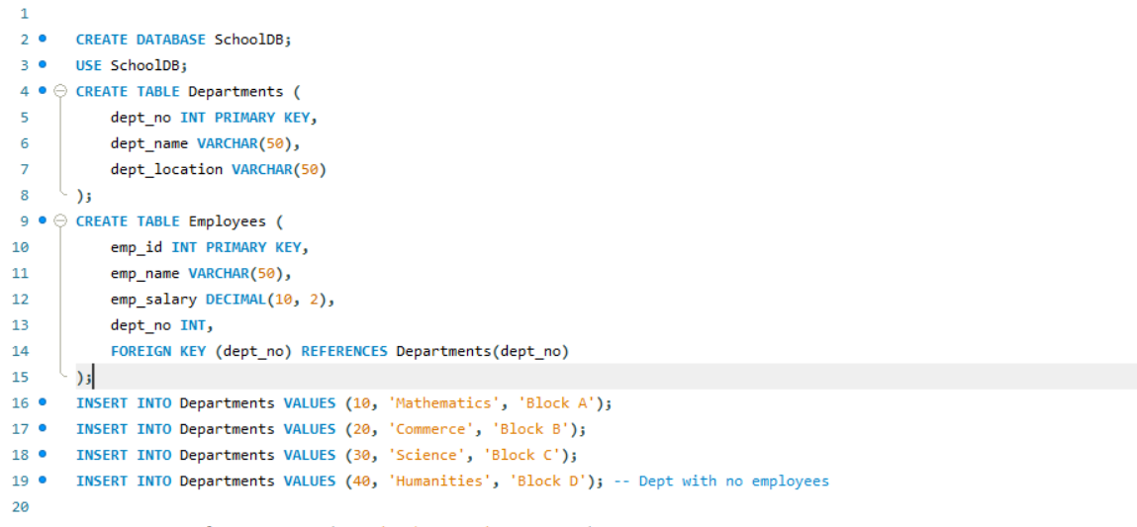

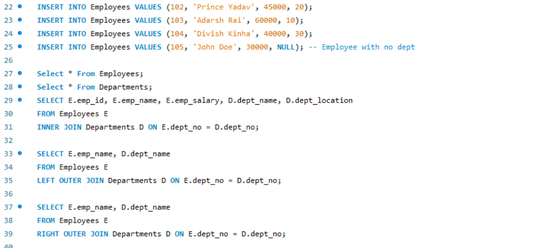

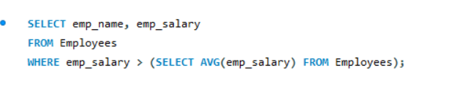

EMPLOYEES TABLE:
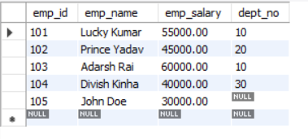

DEPARTMENT TABLE:
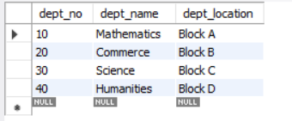

a.
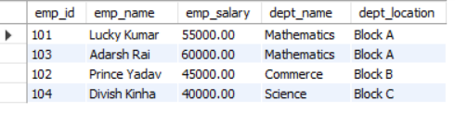

b.
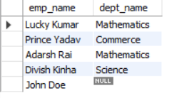

c.
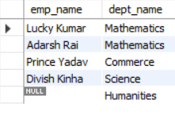

d.
